1. Without using R, determine the result of the following computation. x ¡- c(1, 2, 3) x[1] / x[2]ˆ3 - 1 + 2 \* x[3] - x[2 - 1]

x <- c(1, 2, 3)

x[1] / x[2]^3 - 1 + 2 \* x[3] - x[2 - 1]

x=(1,2,3)

  x[1]=1

 x[2]=

  x[3]=3

 x[1] / x[2]^3 - 1 + 2 \* x[3] - x[2 - 1]

Let's compute each part:

x[1]=1x[1] = 1x[1]=1

x[2]^3=8

x[2−1]=x[1]=1

x[3]=3

8/1​−1+2×3−1

1/8=0.125

0.125-1+6-1

4.125

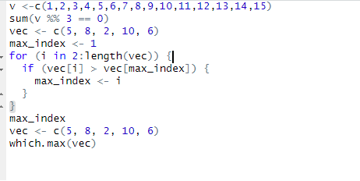

C:\Users\Admin\AppData\Local\Microsoft\Windows\INetCache\Content.MSO\D05024E2.tmp

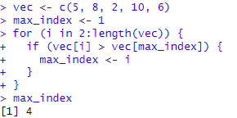

C:\Users\Admin\AppData\Local\Microsoft\Windows\INetCache\Content.MSO\76199F4E.tmp